Eight Discipline Report (8D Report)
To: Google | 8D report No.:
From:：Chicony Power Technology | RMA claim No.: N/A
CC： | Chicony Power P/N: w008r026q
CC： | Customer P/N:
Submit date: 2021/09/14 | Product description: A02
Receive date: 2021/09/14
Subject：SR step over spec
D1.) 問題解決成員:Use Team Approach
主持者 (Team Leader)：Steven Hsiao
內部成員 (Internal Team Members):
ME : Steven Hsiao
外部成員 (External Team Member):
Vendor : Cabletech
D2.)問題說明:Problem Description:
(Note: Use who, what, when, where, why, how, how many to specify the Customer’s problem.)
SR step over spec
超音後的成品, 發現SR的step超過規格, 規格為0±0.2, 實際成品約為0.2~0.25
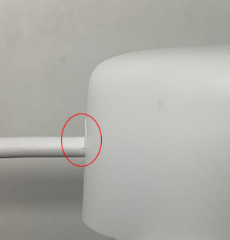
D3.)內部或客戶的暫時解決辦法及實施日期:Implement and Verify Containment Action:
(Note: Internal / external containment action effectiveness and date.)
NA
D4.)不良原因確認: Define and Verify Root Causes:
(Note: Identify and verify all suspect causes, which needs explain why the problem occurred.)
拆解後發現線材的熱縮套管會使DC wire在彎曲時, 將SR向外擠壓, 造成SR傾斜讓step 超過規格 ,
同步將熱縮套管手工剪短後, step值就在規格內, 因此認為過長的熱縮套管使線材bending將SR往外推為問題主因
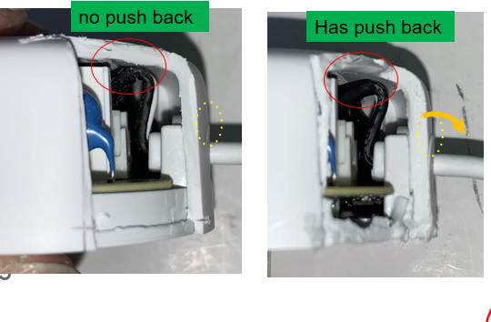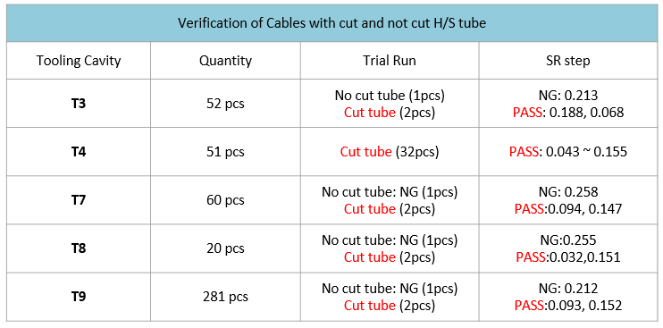

D5.)改善措施:Corrective Action Verification:
(Note: Be make sure the corrective actions is effective in process as well as able to fix the customer complaint problem)
Short term:
Request cable supplier to cut H/S tube to 5 mm.

Long term:
Revise H/S tube length from 7 +2/-1mm to 4 +1/-1mm in 2D spec drawing.
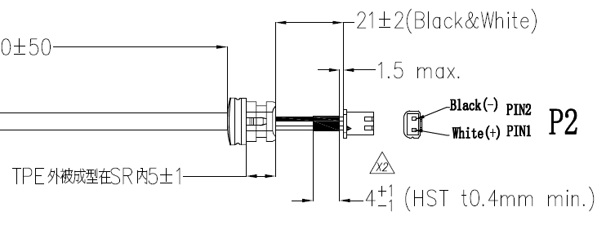

D6.)改善措施實施日期:Implement Permanent Corrective Actions:
(Note: Be provide the phase-in date or lot# of corrective actions implementation in process)
immediately
D7.)預防再發生措施:Prevent Recurrence:
(Note: Modified the management, operating systems, practices, and procedures to prevent recurrence for the problems as well as lessons learned cases.)
Same as D5
D8.)確認並感謝問題解決成員:Check and Congratulate the Team:
(Note: Recognize the collective efforts of the team.)
Thanks to you all！！！
ME:Steven Hsiao ; Vendor : Cabletech

